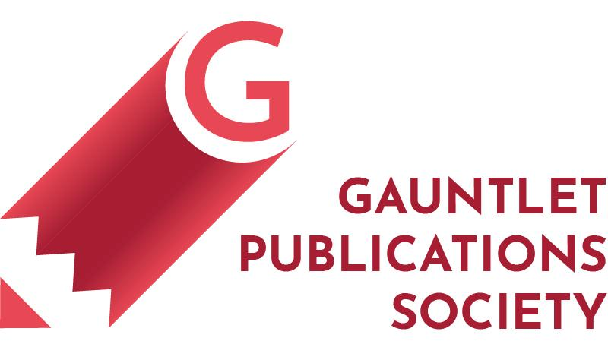

Room 319 MacEwan Student Centre
2500 University Dr. NW
Calgary, AB, T2N 1N4

Managing Editor

The Managing Editor is the operational backbone of the Gauntlet newsroom, working in close partnership with the Editor-in-Chief (EIC) to ensure that the paper’s editorial vision is executed on time, to standard and with consistency across every section. The Managing Editor is the connective tissue between the EIC and the section editors—tracking the story pipeline, maintaining both the editorial calendar, as well as, coordinating print and digital deadlines, and enforcing Canadian Press (CP) style. The Managing Editor will also collaborate with the EIC on operation initiatives that define the year’s editorial program. This role is suited to a meticulous, communicative editor who leads by doing and takes genuine pride in making the newsroom run. This is a salaried contract position beginning June 8, 2026, and ending April 30, 2027, reporting to the Editor-in-Chief.

The following is tentative and subject to change as per the needs of the editorial board:

Managing Editor responsibilities:
- Maintaining and posting regular office hours.
- Assisting the EIC in maintaining and updating the editorial calendar, ensuring all sections have clear submission and editing deadlines for both print and digital publication.
- Tracking the weekly story pipeline across all sections using the newsroom’s story prioritization system, flagging critical and urgent stories to the EIC and relevant section editors.
- Coordinating with section editors and the EIC to manage workflow, prevent bottlenecks, and ensure nothing falls through the cracks between assignment and publication.
- Serving as the primary point of contact for section editors specifically for section editors on deadline and logistics questions, escalating editorial decisions to the EIC as needed.
- Ensuring the print production schedule is being met and ready to be sent to the printers on time at every cycle.

Copy editing standards & support:

- Maintaining and enforcing Canadian Press (CP) style standards across all sections, serving as the newsroom’s primary style resource for editors, reporters, and volunteers.
- Supporting the EIC in the rollout and ongoing use of the newsroom’s CP Style web-chrome browser add-on, helping train editors and reporters on its use.
- Conducting final copy review before sending to the EIC on stories for publication, catching style, accuracy, and consistency issues that section editors may have missed.
- Serve as the Gauntlet’s in-house fact checker on contentious articles filed for the publication, collaborating with section editors on contentious pieces.

Recruitment/training:
- Host workshops on editorial standards and Canadian Press style writing.
- Assist the EIC and Volunteer & Outreach Coordinator (VOC) in the training and orientation of perspective volunteers.
- Assist in representing the Gauntlet at events, pop-ups, print launches, and other various external events.

Editorial duties:
- Attending weekly editorial/pitch meetings.
- Supporting the EIC in the day-to-day management of the editorial team, assisting where asked.
- Being prepared to discuss stories and their deadlines with editors for the upcoming week/month at the editorial meeting.
- Keeping up to date on events and breaking stories which may be relevant to all sections that are relevant to the campus community.
Job requirements:
- Current undergraduate students at the University of Calgary.
- Experience in Canadian Press Style; able to demonstrate ability to apply and teach style standards.
- Strong organizational and project management skills, with a track record of meeting deadlines in a fast-paced environment.
- Able to demonstrate editorial judgement and the ability to manage multiple competing priorities simultaneously.
- Experience working in a supervisory role considered an asset.

Technical skills:
- Copy-editing.
- Interviewing.
- Fact-checking.
- WordPress, recommended.
- Google Workspace (Docs, Sheets, Drive), recommended.
- Click-up or other task-management software, recommended.

Reports to: Editor-in-chief.

Please submit your cover letter, resume and three (3) samples of related writing pieces via email to the Hiring Committee: hiring@thegauntlet.ca.

Deadline for applications is Monday, May 4, 2026, at 4 pm.

